HUMAN INTERACTION WITH COMPUTER BY USING HAND GESTURES

RAVISHANKAR KANDASAMY,
AP/ECE,
Paavai Engineering College,
Namakkal,
ravishankarkandasamypec@paavai.edu.in
NAGAMANI.N
Student,
Paavai Engineering College,
Namakkal,
nagamaninatrajan98@gmail.com
INDHUMATHI.P
Student,
Paavai Engineering College,
Namakkal,
indhumathi31012000@gmail.com

DHARANIPRIYA.S
Student,
Paavai Engineering College,
Namakkal,
dharanipriya1998s@gmail.com

Abstract— In our project, we propose a technique to control the basic computer operations without any keyboard or mouse by hand gestures using PYTHON 2.7. The proposed algorithm recognizes a set of specific hand gestures, namely play, stop, forward, reverse and increase/decrease volume, based on hand untouched interaction with computer. An Ultrasonic sensor is used to sense the hand movements of the user. Our algorithm is based on three phases of operation, namely Image acquisition, segmentation and recognition. This algorithm can be used with various display systems like TV, Laptop, Computer desktop, tablet for fast operation. This project enables the HCI (human – computer interaction) in our day to day activities.
Keywords— Real time, Hand gestures, gesture recognition, human interaction, tracking.

Introduction
A computer system has become a very powerful machine which has been designed to make the human beings tasks easier. Due to which the HCI (human – computer interaction) has become an important part of our lives. Now-a- days, the progress and development in interaction with computing devices has increased so fast that as a human being even we could not have remained left with the effect of this and it has become our primary thing. The technologies have so much surrounded us and has made a place in our lives that we use it to communicate, shop, work and even entertain ourselves. Recently Gesture controlled Laptops or computers are getting very famous. This technique is called Leap motion which enables us to control certain functions on our computer/Laptop by simply waving our hand in front of it. It is very cool and fun to do it, but these laptops are really priced very high. So, in this project let us try building our own Gesture control Laptop/Computer by combining the Power of Arduino and Python. Now-a-days most of the users use keyboard, mouse, pen, Joysticks etc. to interact with computers, which are not enough for them. Soon, these, communication and display will become a bottle neck and the advancement in these technologies will be required to make the system as natural as possible. It is required to provide a way to explore the use of gestures in HCI so that it can be interpreted by computers. The static and/or dynamic form of gestures of human arm, hand and even some other body parts require to be measurable by machine for the HCI interpretation. The motivation behind this research is to make an interaction between human and computer using various applications running on computer by aiming basic shapes made by hand. Our hand movements have an important role while interacting with other people, as they convey very rich information in many ways. According to this thought hand gestures would be an ideal option for expressing the feelings, or controlling the dynamic applications of computers through easier hand gesture. In compare to other body parts, human hand which has been considered as a natural means for human to human interaction, has been used widely for gesturing and can be best suitable for communication between human and computer.

II. EXISTING SYSTEM

In decades, due to computer software and hardware technologies of continuous innovation and development, the social life and information technology have a very close relationship in the twenty-first century. In the future, especially the interfaces of consumer electronics products (e.g. smart phones, games and infota1inment systems) will have more and more functions and be complex. How to develop a convenient human-machine Interface (Human Machine Interaction/Interface, HMI) for each consumer electronics product has become an important issue. The traditional electronic input devices, such as mouse, keyboard, and joystick are still the most common interaction way. In recent years, the gesture control technique has become a new developmental trend for many human-based electronics products, such as computers, televisions, laptops, tablets and games.

III. Proposed system
In our proposed system, we use Ultrasonic sensor to sense the hand moment made by the user. We develop a technique for recognizing the gestures made by user using PYTHON 2.7 and implement this technique to control the computer without using keyboard or mouse. Here, three major steps are involved, they are acquisition, hand segmentation and recognition based on the following operations can be performed, The audio/video will be,
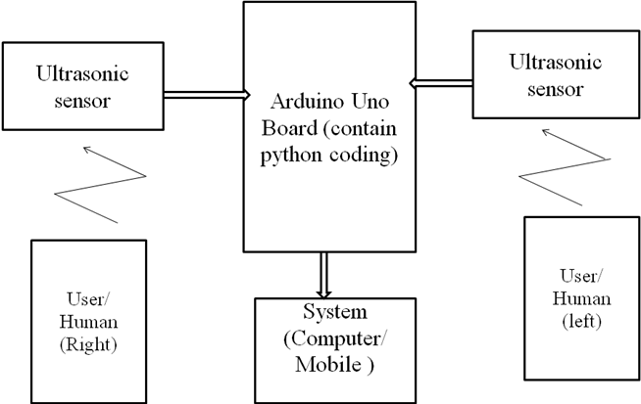
Figure: Block diagram for proposed system

1. Play, stop, forward, reverse, increase/decrease volume.
2. Pickup and manipulate the virtual object
3. No physical contact with computer.
4. Communicate at a distance

The Arduino Uno is a microcontroller board based on the ATmega328. It is a programmable micro controller for prototyping electromechanical devices. It has 14 digital input/output pins (of which 6 can be used as PWM outputs), 6 analog inputs, a 16 MHz ceramic resonator, a USB connection, a power jack, an ICSP header, and a reset button. We will use two Ultrasonic sensors to determine the position of our hand and control position. Ultrasonic sensor is used to measure distance range of 2cm-400cm with accuracy of 3m. Python is a general-purpose programming language created in the late 1980 s That’s used by thousands of people to do things from testing microchips at intel, to powering Instagram, to building video games with the Pygames library.

- Ultrasonic Sensor

An Ultrasonic sensor is a device that can measure the distance to an object. Measuring the time between emission and reception. The sensor head emits an Ultrasonic wave and receives the wave reflected from the target.

Front view Back view
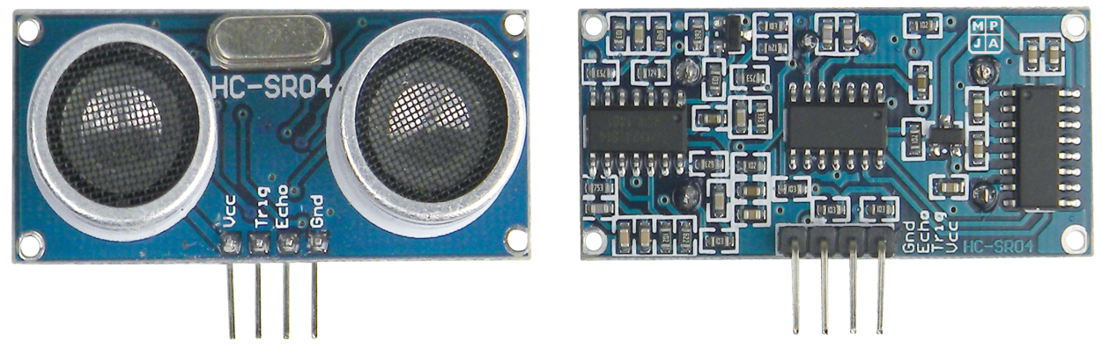

Figure :Ultrasonic Sensor
As shown above the HC-SR04 Ultrasonic (US) sensor is a 4-pin module, whose pin names are Vcc, Trigger, Echo and Ground respectively. This sensor is a very popular sensor used in many applications where measuring distance or sensing objects are required. The module has two eyes like projects in the front which forms the Ultrasonic transmitter and Receiver.

- Arduino Board

The Arduino Uno is a microcontroller board based on the ATmega328 (datasheet). Along with ATmega328P, it consists other components such as crystal oscillator, serial communication, voltage regulator, etc. to support the microcontroller.

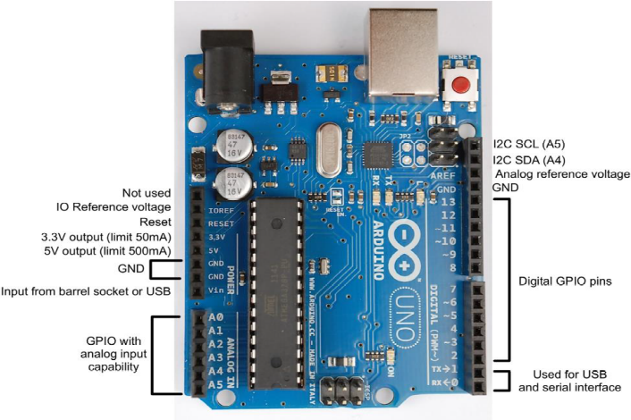

Figure: Diagram for ardiuno uno Board

It has 14 digital input/output pins (of which 6 can be used as PWM outputs), 6 analog inputs, a 16 MHz ceramic resonator, a USB connection, a power jack, an ICSP header, and a reset button. It contains everything needed to support the microcontroller; simply connect it to a computer with a USB cable or power it with a AC-to-DC adapter or battery to get started. Microcontrollers are used in automatically controlled products and devices, such as automation machine control systems and other embedded systems. The ATmega328p is a single-chip microcontroller created by Atmel in the mega AVR family.

- Software Description

Python is an interpreted high-level programming language for general purpose programming. Created by Guido van Rossum and first released in 1991, python has a design philosophy that emphasizes code readability.

Notably using significant white space. It provides Constructs that Enable clear programming on both small and large scales. In July 2018, Van Rossum stepped down as the leader in the language community after 30 years.

Python Features a dynamic type system and automatic memory management. It supports multiple programming paradigms, including object-oriented, Imperative, Functional, procedural and has a large and comprehensive standard library.

Python 2.7 interpreters are available for many operating systems. C Python, the reference implementation of python, is open source software and has a community-based development model, as do nearly all of python’s other implementations. Python and C Python are managed by the non-profit python software foundation.
- Gesture Controlled Computer in Action:
Make the connections as defined above and upload the Arduino code on your Arduino board. Then use the python script below and launch the program on your laptop/computer.
Now you can play any movie on your computer using the VLC media player and use your hand to control the movie as shown in the video given below.

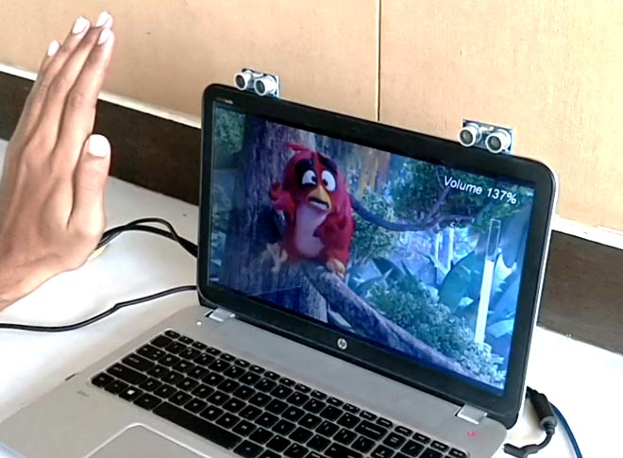
Figure: The gesture control the computer
Hope you understood the project and enjoyed playing with it. This is just a demo and you can use your creativity to build a lot cooler gesture controlled stuff around this. Let me know if this was useful and what you will create using this in the comment section and I will be happy to know it.
IV. Result and Discussion
Human computer interaction based on human gesture recognition is an important research subject in current intelligent human-computer interaction. The gesture recognition based sensor to capture the gesture information, which do not need to buy expensive equipment, and it is more natural convenient in operation and people oriented. A simple word digital recording system is developed, combining the gesture recognition in human-computer interaction. This research still needs to be improved. In the hand gesture tracking and real-time recognition, we also need to increase the kind of gesture and further improve the recognition speed and accuracy.

Advantages

1. It is easy to design and manufacture as all the components are easily available.
2. It is portable and hence can be placed anywhere.
3. It has low cost of manufacturing
4. The Microcontroller can be reprogrammed if any modification is required
5. Wireless makes ease of operation
6. Due to wireless communication data rate is faster
7. No need of lengthy wires
8. Power consumption is less.

Applications

This hand gesture recognition system is very fast in day-to-day technical solutions. Its main applications are,

1. For controlling the traffic signals as per the wish of traffic controller to reduce the problem of traffic jam at peak hours
2. To control the mouse so that physically handicapped people can use it and it mouse will not be inefficient to use while travelling
3. Enabling very young children to interact with computer
4. Designing techniques for forensic identification
5. Recognizing sign language
6. Medically monitoring patients
7. Navigating and/or manipulating virtual environments
8. Communicating in video conferencing
9. Distance learning / tele- teaching assistance
10. Graphic editor control.

V. Conclusion

The proposed work will help to eliminate the traditionally completely. It only requires sensor to capture Input image. This would lead to a new generation of human computer interaction in which no physical contact with device is needed. Anyone can use the system to operate the computer easily, by using gesture command.

REFERENCE

- Anupam Agrawal, Rautaray.S and Siddharth, (2012) “Vision based hand gesture recognition for human computer interaction”, A survey DOI 10.1007/s10462-012-9356-9, Springer Science+Business Media Dordrecht
- Bor-ShennJeng, Chien-Cheng Lee and Cheng-Yuan, (2010) “Fingertip-writing alphanumeric Character Recognition for Vision-based Human Computer Interaction”, International Conference on Broadband, Wireless Computing, Communication and Applications 978-0-7695-4.
- Burande.C, Choudhary.N and Tugnayat.R, (2010) “Advanced Recognition Techniques for Human Computer Interaction”, IEEE, Vol 2 pp., 480-48.
- Chekima.A, Howe.L and Wong.F, (2008), “Comparison of Hand Segmentation Methodologies for Hand Gesture Recognition”, IEEE-978-4244-2328-6.
- Papamarkos.N , Stergiopoulo.E, (2006) “A New Technique for Hand Gesture Recognition”,IEEE-ICIP,pp., 2657-2660.Sushmita Mitra, Senior Member, IEEE, and Tinku Acharya, (2007) “Gesture Recognition: A Survey” Senior Member, IEEE.
- Sushmita Mitra, Senior Member, IEEE, and Tinku Acharya,(2007) “Gesture Recognition: A Survey” Senior Member, IEEE.

